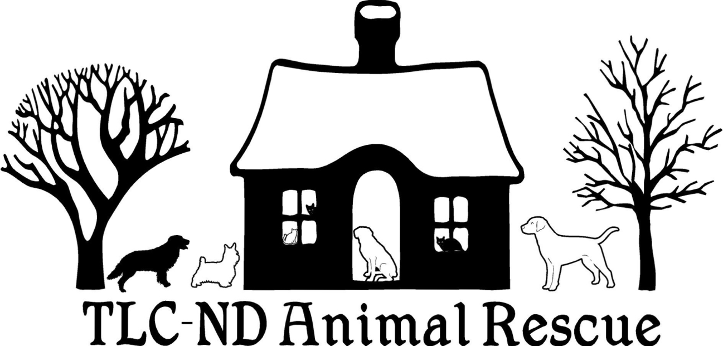

Dog Adoption Application
tlcnd@gondtc.com, 701-662-4357 or 701-230-3728

Please note that if any information provided by you in the course of completing the application process is found to untrue, your application will automatically be denied and you are ineligible to adopt ANY pet from TLC-ND Animal Rescue. LH

- Just respond N/A if a question does not apply to your situation. If you need more room to answer a question just write it on the back page of the application.

DOG YOU ARE INTERESTED IN ADOPTING IS:

1. Your full legal Name:

2. Home address, City, State, Zip Code:

2a. Mailing address if it is different

3. Telephone: (cell), (home)

4. E-MAIL:

5. BEST WAY AND TIME TO CONTACT:

6. OCCUPATION and EMPLOYER: Name, Address and Telephone:

7. Date of birth:

8. What type of home do you live in? (Apartment, townhome, one story, two story etc.?)

9. Do you have a fenced in yard? Yes or No If so, what are the fence specifics? (Materials, height, how big of an area)

10. Do you rent or own your own home?

10a. If renting, what is your landlord's name and telephone number?

10b. If renting, written permission must be given by landlord or management company.

11. 1st PERSONAL REFERENCE NAME, TELEPHONE and E-MAIL:

12. 2nd PERSONAL REFERENCE NAME, TELEPHONE and E-MAIL:

13. VETERINARIAN REFERENCE:

13a. VETERINARY RECORDS ARE UNDER WHAT NAME?

14. HOW MANY PEOPLE LIVE IN YOUR HOME?

14a. How many are under the age of 21:

14b. Names of those under 21:

15. DOES ANYONE LIVING AT HOME HAVE ALLERGIES?

16. Are all members of the household in favor of adopting?

16a. If anyone is not in favor of adopting, who is that person and what is their reason?

NOTE: If anyone in the home is NOT in favor of adopting, there is no need to continue filling out this application. TLC-ND Animal Rescue will not place any rescued animal in an environment where even one member of the does not want it there. This is a non-negotiable item with TLC-ND Animal Rescue.

17. How long have you been looking for a dog?

18. Why do you want a dog at this time?

19. What is it about the dog you're interested in that appeals to you?

20. Are you aware of the financial obligations in owning a dog?

21. Will you provide yearly veterinary exams and keep this dog up to date on all vaccinations as necessary?

22. Do you agree to obtain a Rabies vaccination prior to this pet's vaccination expiring?

23. If necessary, do you agree to spay or neuter your new pet in a timely manner (within 30 days of adoption)(or when he/she is 6 months of age)?

24. Do you have pets living in your home now?

24a. Names/Dog or Cat/Age(s)

25. ARE ALL OF YOUR PETS CURRENT ON THEIR VACCINATIONS?
YES or NO If yes, this will be verified during the application process. If your answer is no, why is that?

26. ARE ALL OF YOUR PETS SPAYED OR NEUTERED? Yes or No
If yes, this will be verified during the application process If your answer is no, why is that?

Please note that TLC-ND Animal Rescue will not approve an adoption application if your existing pets are not spayed or neutered, OR up to date on their vaccinations. If there is a medical reason, your veterinarian will need to confirm that for you to be considered as a prospective adopter.

27. Anything else you'd like to add regarding your current pets (ages, general health, personality type, etc.)?

28. If applicable, how does your dog react to other dogs?

29. Have you ever given away, sold, abandoned, surrendered or had a pet put to sleep?

29a Please explain the situation if you answered yes.

30. In addition to any pet that may have been mentioned in you answer to question 29, please list previous pets that have been YOUR responsibility and a part of your life. Names and ages (if that is known).

31. Has any pet disappeared, been killed or injured, or mistreated while in your care?

31a. If yes, please explain the situation.

32. Explain conditions or circumstances that would cause you to give up any pet.

33. Who would you contact to help with the situation in #29 if necessary?

34. Have you adopted a pet before?

34a. If yes, through whom?

35. List size or breed preference and qualities that would best suit your home:

36. What would you do if dog chews belongings or shows destructive
behavior, what action would you take to correct that behavior?

37. Where will this dog be when all have left the house? Confined at all?

38. What is the longest amount of time that this dog will be left alone? Please explain.

39. Where will this dog sleep? Please explain.

40. Where will the dog be exercised and how often?

40a. Who is primarily going to be responsible for making sure the dog gets plenty of physical activity?

41. When and where will the dog be allowed off leash?

42. Are you willing to work with this dog on any issues?

43. How long do you feel pets need for an adjustment period when they are newly placed?

44. Are you willing to allow a home visit? Yes or No
**A home visit takes approximately 30 minutes of your time and is a visit at your residence to meet all people who live in the home, along with any pets, to determine that you are going to provide a safe and loving home for the pet that you are applying to adopt.

45. Have you answered all questions truthfully and honestly?

46. How did you hear about this dog?

47. Todays date:

---------------------------------------------------------------------------------------------------------

For office use only:
Subject:
WARNINGS: Permission has been given to use this "revised" adoption form similar to that which 4 Luv of Dog Rescue in Fargo uses.

