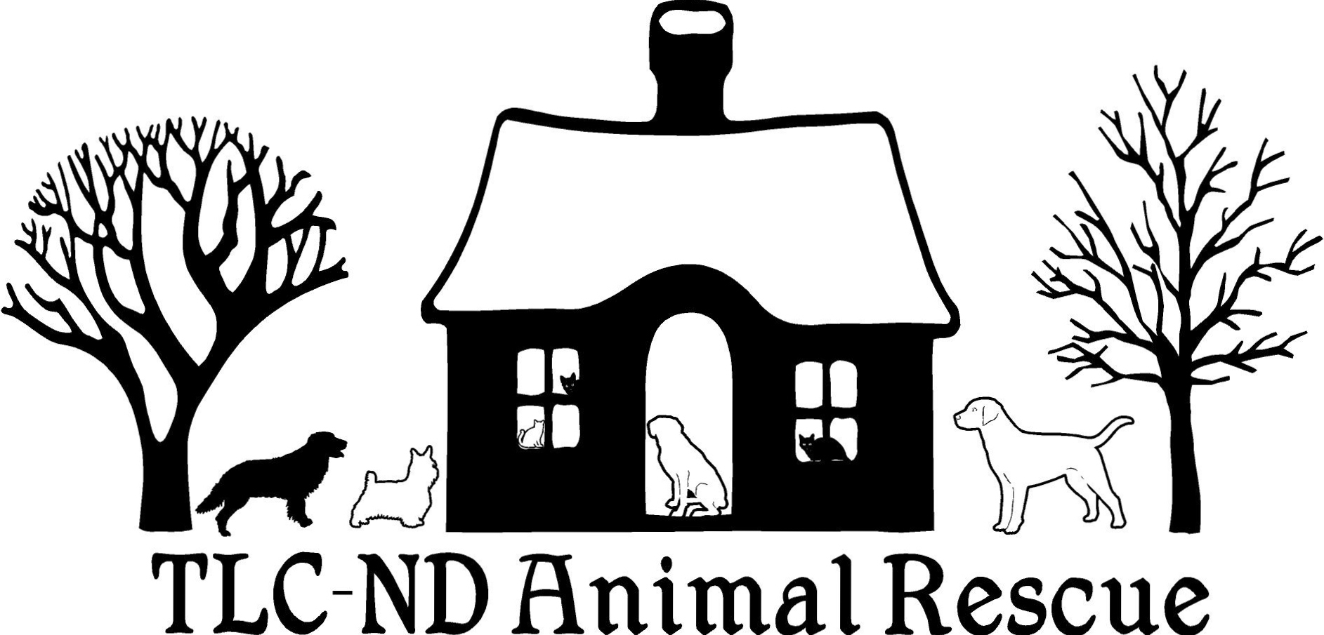
P.O. Box 1132, Devils Lake, ND 58301
701.662.4357, tlcnd@gondtc.com

Cat Adoption Application & Agreement

Cat’s Name _______________________________________________
Color & Description ____________________________________________________________________
Sex M F Age/Date of Birth ______________ Weight __________ DSH DMH DLH
Adopter’s Name ___________________________________________________
Address __________________________________________________________
City ________________________________________ State ______ Zip Code _________________
Cell phone ______________________________ Home phone ________________________
E-Mail __________________________________________________
How many children are in the home? ______ Age(s) __________________________________________
Do you own or rent your home? Own Rent
If renting, do you have permission to have a pet? Yes or No
Landlord’s Phone # & Name ______________________________________________________________
*I will contact your landlord for confirmation.
Name of your veterinarian _________________________________________________________________
# of pets in the home at present: Dogs ______ Cats _____ Ages(s) ___________________________
Are these pets spayed/neutered? Yes or No If not, why not? ________________________________
____________________________________________________________________________________________
Have you had pets in the past? Yes or No What happened to the ones you no longer have? ___________
_______________________________________________________________________________________________
Where will this cat be kept during the day? ____________________________ At night? __________________________
In what situation would you consider giving up this cat? ________________________________________________________
What would happen to this cat if you were to move? ___________________________________________________________

This constitutes not only an agreement with TLC-ND Animal Rescue/LuAnn Hinderscheit, but also a promise to my newly adopted cat. Please initial each statement.
______ I agree to make my adopted cat a part of the family.
______ I agree to keep my cat INDOORS at all times and will ONLY allow him/her outside in a safe area with VERY close supervision. This provision may be tweaked dependent on the cat in question.
______ I agree to provide my cat with necessary vaccinations, as determined by my veterinarian.
______ I will obtain immediate veterinary care if my cat becomes ill or injured.
______ I will NOT have my cat de-clawed for any reason.
______ I WILL have my cat spayed/neutered at the age of six months or when he/she weighs a minimum of 3 pounds.
______ If my cat develops behavior problems, I agree to contact TLC-ND Animal Rescue (LuAnn Hinderscheit) or a behavior specialist.
______ I understand that TLC-ND Animal Rescue/LuAnn Hinderscheit cannot guarantee the health, temperament or training of my adopted cat and hereby release TLC-ND Animal Rescue/LuAnn Hinderscheit from any claim, cause of action or liability for any injury or damage to persons or property once the cat is in my possession.
______ I agree not to abuse or neglect my cat in any way. If TLC-ND Animal Rescue/LuAnn Hinderscheit determines the cat has been abused or neglected, I authorize them to remove my cat from my premises without process of law. I agree to waive all claims to trespass or damages.
____ I agree that if TLC-ND Animal Rescue/LuAnn Hinderscheit determines that any of the provisions of this agreement have not been fully complied with, I will return this cat to TLC-ND Animal Rescue/LuAnn Hinderscheit upon demand. If I fail to return this cat, TLC-ND Animal Rescue/LuAnn Hinderscheit will have the right, without further notice or demand, to enter the premises where the cat may be, and remove the cat without process of law. I agree to waive all claims for trespass or damage.
RETURN POLICY -- If I cannot keep the cat I am adopting for its lifetime, I agree to contact TLC-ND Animal Rescue/LuAnn Hinderscheit to discuss options. If necessary, the cat can be returned to TLC-ND Animal Rescue/LuAnn Hinderscheit.

Deposit/Payment __________________ (Adoption fee $__________)

Signature of Adopter ___________________________________ Date ________________________

Signature of Guardian & Relationship (if adopter is under the age of 18)

______________________________________________ Date ________________________

TLC-ND Animal Rescue Representative ____________________________________________________

Date ________________________________

---------------------------------------------------------------------------------------------------------
For office use only: Subject:

WARNINGS:

**NOTE: Portions of this cat application/adoption form are copied with permission from CATS Cradle Shelter per Gayle.

